Typical Retek 10 - Sizing Input Requirements & Sizing Process

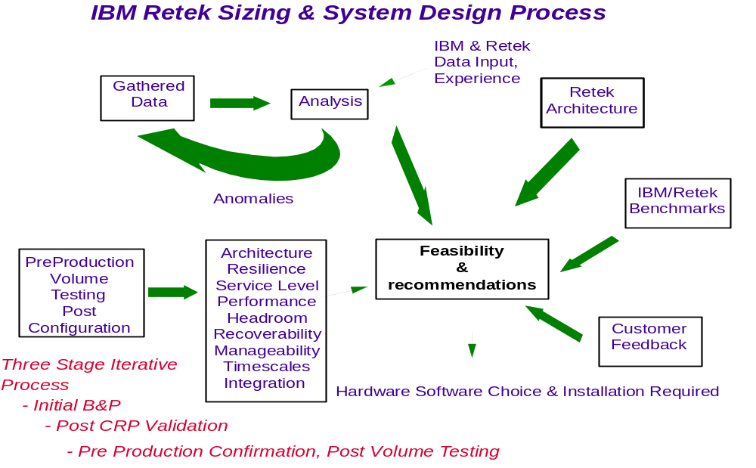

Typical Input Requirements

